1. **Analysis of Developmental Outcomes by Socioeconomic Status (SES)**

**Objective**

To assess the association between socioeconomic status (SES) and long-term neurodevelopmental outcomes (motor, language, cognitive and social-emotional scores), while adjusting for potential confounding variables: birth weight and gestational age.

**Data & Variables**

Outcomes (continuous, non-normally distributed):

* Bayley’s scores:

1. Motor
2. Language
3. Cognitive
4. Social-emotional

Predictors:

* SES group (categorical: Disadvantaged [reference], Average, Affluent)
* Birth weight (continuous)
* Gestational age (continuous)

**Statistical Methodology**

**Linear Regression Models**

* For each outcome, a **linear regression model** was fitted with:
  + SES group (factor)
  + Birth weight (g)
  + Gestational age (weeks)

lm(outcome ~ SESgroups + birth_weight + gest_age, data = data)

**Robust Standard Errors (Huber-White Sandwich Estimator)**

* Given the **non-normal distribution** of outcome variables and potential **heteroskedasticity** in residuals, **robust standard errors** were used to obtain **valid inference** (confidence intervals and p-values).
* This was implemented using:

coeftest(model, vcov = vcovHC(model, type = "HC1"))

* The **HC1 estimator** adjusts standard errors to be heteroskedasticity-consistent without assuming normally distributed residuals.

|  |  |  |  |  |
| --- | --- | --- | --- | --- |
| **Outcome** | **SES: Average vs Disadvantaged** | **SES: Affluent vs Disadvantaged** | **Birth Weight** | **Gestational Age** |
| Motor | +5.4 points (p = 0.048) * | +8.1 points (p = 0.008) ** | +0.003 per unit (p = 0.413) | +0.24 per unit (p = 0.62) |
| Cognitive | +6.9 points (p = 0.023) * | +10.2 points (p = 0.006) ** | +0.007 per unit (p = 0.11) | -0.13 per unit (p = 0.82) |
| Language | +9.8 points (p = 0.014) * | +9.9 points (p = 0.030) * | +0.012 per unit (p = 0.015) * | -0.5 per unit (p = 0.44) |
| Social-Emotional | +6.8 points (p = 0.139) | +14.2 points (p = 0.009) ** | +0.00037 per unit (p = 0.96) | -0.504 per unit (p = 0.64) |

**Table 1.** Table outlining the estimated differences in mean scores for children from average and affluent SES groups compared to the disadvantaged reference group.

1. **Analysis of ASD Referral and SES**

To examine whether SES is associated with likelihood of referral for autism spectrum disorder (ASD), while adjusting for potential confounding variables: birth weight and gestational age.

**Data & Variables**

Outcome:

* Autism referral (binary; referred vs not referred for ASD)

Predictors:

* SES group (categorical: Disadvantaged [reference], Average, Affluent)
* Birth weight (continuous)
* Gestational age (continuous)

**Statistical Methodology**

**Logistic Regression Model**

* A **logistic regression model** was fitted with:
  + SES group (factor)
  + Birth weight (g)
  + Gestational age (weeks)

glm(asd ~ SESgroups + gest_age + birth_weight, data = data, family = "binomial")

|  |  |  |  |  |
| --- | --- | --- | --- | --- |
| **Predictor** | **Odds Ratio (OR)** | **95% CI** | **p-value** | **Interpretation** |
| **SES: Average vs Disadvantaged** | 0.25 | 0.037 – 1.01 | 0.085 | Children from Average SES had ~75% lower odds of ASD referral compared to disadvantaged, but this was marginally non-significant. |
| **SES: Affluent vs Disadvantaged** | 0.10 | 0.013 – 0.44 | 0.006 ** | Children from affluent SES had ~90% lower odds of ASD referral compared to disadvantaged (statistically significant). |
| **Gestational Age** | 0.88 | 0.66 – 1.15 | 0.358 | Per unit increase of GA there is a ~12% lower odds of ASD referral, however this is not statistically significant. |
| **Birth Weight** | 1.00 | 0.999 – 1.00 | 0.635 | No association between birth weight and ASD referral found. |

**Table 2.** Results from a logistic regression model examining the association SES and the likelihood of referral for ASD, controlling for birth weight and gestational age. Odds ratios (ORs) with 95% confidence intervals are shown for each predictor, comparing children from average and affluent SES backgrounds to those from the disadvantaged reference group.

1. **Analysis of Bayley Scores by Socioeconomic Status**

Bayley-III domain scores (motor, cognitive, language, social-emotional) were not normally distributed (confirmed by histogram visualizations, Q-Q plots, Shapiro-Wilk tests, and skewness/kurtosis metrics). Therefore, non-parametric methods were used to assess differences across SES groups (Disadvantaged, Average, Affluent).

**Statistical Methodology**

* **Kruskal-Wallis** tests were used to assess whether median scores differed across the three SES groups for each outcome.
* Where overall group differences were significant or borderline, **Dunn’s post-hoc tests** with **Bonferroni correction** were applied to identify specific pairwise differences.
* Summary statistics (mean, median) were calculated by SES group for descriptive comparison.
* Boxplots with annotated *p*-values from Dunn’s tests visualize significant and borderline comparisons.

**Motor Scores by (SES)**

A Kruskal-Wallis test indicated a statistically significant difference in Bayley motor scores across SES groups (chi-squared = 8.27, *p* = 0.020). Post-hoc comparisons using Dunn’s test with Bonferroni correction revealed:

* Disadvantaged vs. Affluent: significant difference (*p* = 0.0061), with infants in the Affluent group scoring higher.
* Disadvantaged vs. Average: borderline significant (*p* = 0.0631).
* Average vs. Affluent: not statistically significant (*p* = 0.175).

|  |  |  |  |
| --- | --- | --- | --- |
| **SES Group** | **n** | **Mean Score** | **Median Score** |
| **Disadvantaged** | 66 | 92.3 | 94 |
| **Average** | 303 | 97.9 | 100 |
| **Affluent** | 90 | 100.6 | 103 |

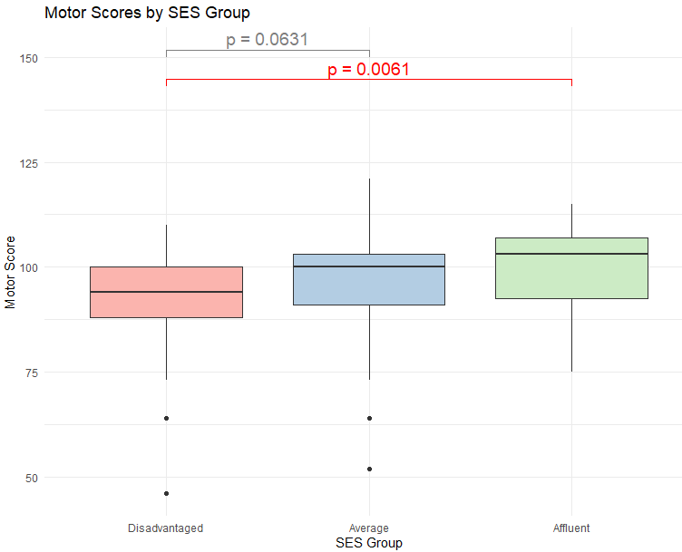

**Cognitive Scores by SES**

The Kruskal-Wallis test revealed a significant difference in cognitive scores across SES groups (chi-squared = 7.72, *p* = 0.021). Post-hoc Dunn's test with Bonferroni correction showed:

* Disadvantaged vs. Affluent: significant difference (*p* = 0.0094)
* Disadvantaged vs. Average: significant (*p* = 0.0382)
* Average vs. Affluent: not significant (*p* = 0.372)

|  |  |  |  |
| --- | --- | --- | --- |
| **SES Group** | **n** | **Mean Score** | **Median Score** |
| **Disadvantaged** | 66 | 97.4 | 100 |
| **Average** | 303 | 104.5 | 105 |
| **Affluent** | 90 | 107.9 | 105 |

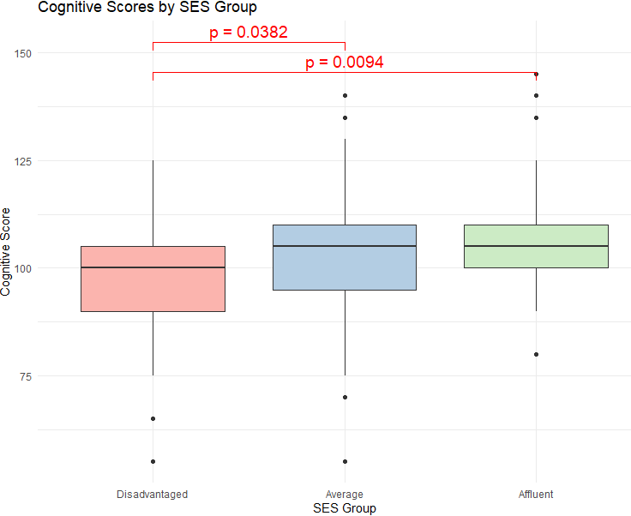

**Language Scores by SES**

A Kruskal-Wallis test revealed a borderline significant difference in language scores across SES groups (χ² = 5.95, *p* = 0.051). While the omnibus test does not meet the conventional alpha level of 0.05, post-hoc pairwise comparisons using Dunn's test with Bonferroni correction identified the following:

* Disadvantaged vs. Average: significant difference (*p* = 0.0263)
* Disadvantaged vs. Affluent: borderline (*p* = 0.0639)
* Average vs. Affluent: no difference (*p* = 1.000)

|  |  |  |  |
| --- | --- | --- | --- |
| **SES Group** | **n** | **Mean Score** | **Median Score** |
| **Disadvantaged** | 66 | 84.2 | 89 |
| **Average** | 303 | 94.2 | 94 |
| **Affluent** | 90 | 94.4 | 94 |

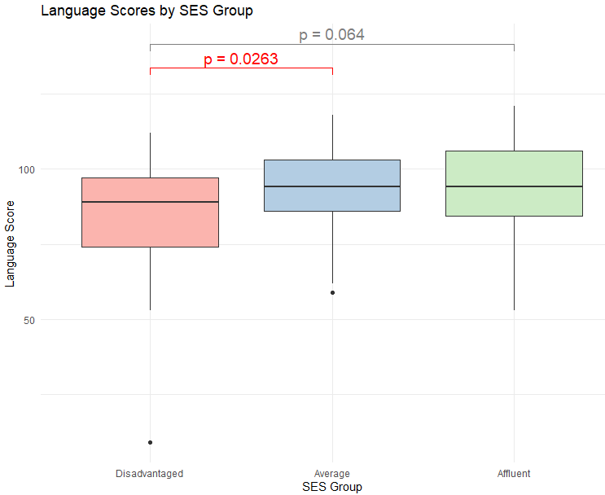

**Social-Emotional by SES**

A Kruskal-Wallis test showed a **statistically significant** difference in social-emotional scores across SES groups (χ² = 6.91, p = 0.032), indicating that at least one group differs in median scores.

**Dunn's post-hoc test with Bonferroni correction** revealed the following pairwise comparisons:

* **Disadvantaged vs. Affluent**: significant difference (p = 0.0150)
* **Disadvantaged vs. Average**: not significant (p = 0.2686)
* **Average vs. Affluent**: borderline (p = 0.0789)

|  |  |  |  |
| --- | --- | --- | --- |
| **SES Group** | **n** | **Mean Score** | **Median Score** |
| **Disadvantaged** | 66 | 92.5 | 100 |
| **Average** | 303 | 99.1 | 100 |
| **Affluent** | 90 | 106.6 | 110 |

